

Biorock: Electric Reefs
Text and Photos By Brandon Cole
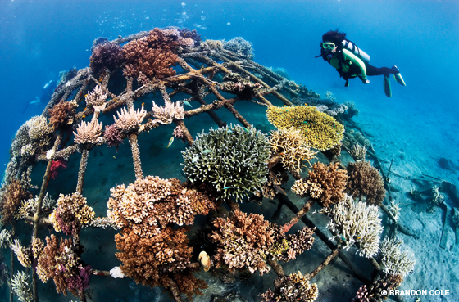
Jump starting coral reef restoration
It sounds like sorcery, a marine-style Frankenstein project: Graft bits of coral onto a rebar skeleton, shock it with electricity, and boom, "it's alive!"
With coral reefs besieged on all fronts, it's past time for thinking outside the box. One group, the Global Coral Reef Alliance, has literally taken charge.
Their Biorock® "reefs," metal and wire-mesh constructs in the shape of domes, tunnels and even a giant sea turtle, are growing corals and restoring degraded coastal reef habitats in 20 countries. Wired to existing onshore electricity sources, solar panels, windmills, and tidal and wave generators, low-voltage direct current flows through the structure, causing minerals in the seawater to precipitate onto the steel frame, resulting in the formation of a limestone layer. Scientists then attach small sprigs of salvaged coral, which quickly become cemented into place by the accumulating limestone. These transplants grow very rapidly, two to six times faster than the normal rate of growth. Others find this fertile substrate ideal as well; drifting wild coral larvae recruits often settle down to sprout with vigor.
Biorock corals are also better able to cope with environmental stresses such as pollution, sedimentation and climate change. In the catastrophic 1998 El Niño bleaching event, 50-80 percent of corals on electric reefs in the Maldives survived dramatically elevated water temperatures as opposed to just 5-10 percent survival rates on adjacent off-grid reefs.
Biorock technology presents an effective opportunity not only to jump start coral reef restoration projects, but also to create vital habitats, build fish populations and support local communities through enhanced diving and snorkeling ecotourism. It can even aid in the prevention of beach erosion. But what is really needed to supercharge these conservation efforts? As with many others, Biorock needs increased funding and governmental support for widespread implementation.
For more information, visit www.globalcoral.org.
© Alert Diver — Winter 2011

