The Tide-Energy Project
Near the Mouth of the Amazon
- a brief, illustrated overview –
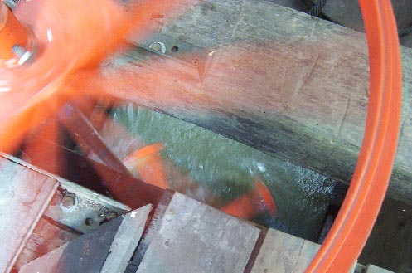
View from above of the main pulley (foreground)
being turned by a Gorlov Helical Turbine in the water below
Note: Helical turbine technology can be adapted for use at different scales in ocean, tidal, and river currents throughout the world.
Scott Anderson, Ph.D.
Project Coordinator
e-mail: sdand@bellsouth.net
May 2006

The Tide-Energy Project near the Mouth of the Amazon
Applying helical turbine technology
at a small scale for rural communities
The project goal: use tidal energy to generate electricity. This project has developed technology to generate electricity on a small scale using tidal energy. It will enable rural residents near the mouth of the Amazon to meet energy needs in a way that is environmentally sound, decentralized, and economical.
Tidal energy: clean, renewable, and proven. The advantages of the tide as a non-polluting and sustainable energy resource are clear. But it may be difficult to capture that energy at sea or on a coast. Conditions near the mouth of the Amazon do, however, offer that possibility. This is proven by the use of tidal energy to power more than 30 sugar cane mills in the region in the past. In fact, this project began by studying their traditional technology. As we will show, with modern technology there is no doubt that it is practical and efficient to capture tidal energy under the same natural conditions.
A requirement: decentralized technology. More than 100,000 rural residents live dispersed in the area where the tide-powered mills were located. They have no possibility of receiving centrally generated electricity, because power lines are uneconomical to reach them. Only decentralized technology can meet their demand. Currently, the options available to them are solar panels and diesel generators. Our tide-energy technology offers them an economical option, one that can be installed at less than half the cost of solar panels and operates much more cheaply than diesel generators.
-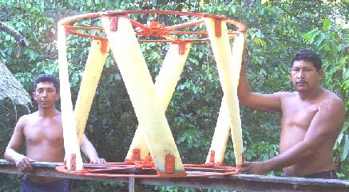
Rural artisans assembled, installed, and operate this 6-blade Gorlov Helical Turbine
An important breakthrough: the helical turbine. The technology we have developed uses jetties to force the flow of tidewater through a duct and run a helical-blade turbine, shown above. This turbine is about 50% more efficient in free flow than conventional, straight-blade versions and, when operating in a duct, may attain an efficiency of nearly 70%. This innovative design has been developed and tested by Professor Alexander Gorlov of Northeastern University, who is a consultant to the project.
Implementation: the field station. We have implemented this technology at our field reaearch station, shown below.
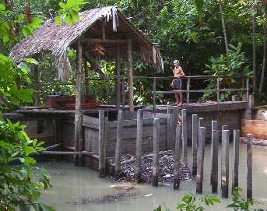
Managing tidal flow with two jetties, a duct, and a gate.
Location. The field station was built on Combu Island near the mouth of the Amazon. It is located in a rural community about one half-hour by boat from Belém, the largest city in the region.
Site and tide. The station sits near the mouth of a closed tidal basin that fills and empties twice a day. The range of the tide in this region is from 1.5 to 3.5 m (5 to 11½ ft), depending on the phase of the moon and season of the year. Because of the immense discharge of the Amazon, the tidewater there is fresh, year-round.
Jetties and duct. The man in the figure is standing on one of the two jetties that extend from the banks of the stream and force the flow of tidewater, both rising and falling, through a duct built on the streambed. Posts and screens at both ends of the duct protect the helical turbine mounted in it from debris.
Gate and head. In addition to managing tidal flow by forcing it through the duct, the duct itself can be closed with a gate. This is done at low and high tide to briefly delay the flow into or out of the stream and hasten the development of a low head of water. When the head is sufficient for the turbine to operate effectively, the gate is opened.
Environmental impact. The environmental impact of this technology is minimal. Although the tidal flow is managed, the stream still fills at high tide and empties completely at low tide, as it would under natural conditions. Shrimp and small fish pass unharmed through the screens and turbine, and larger fish can move through passages built in the jetties, so natural conditions are also maintained for aquatic life.
Generating equipment: the helical turbine, transmission, and generator. The generating system installed at the field station is shown below.

Configuration. A helical turbine (bottom) rotates on a shaft that joins it to a pulley (middle). The pulley turns an alternator (right) by means of a belt.  The alternator charges batteries to store the energy captured, as is usual with other intermittent sources—solar and wind—when used off the grid.  All of the equipment in this system was manufactured or purchased locally, except for the helical turbine blades themselves. | 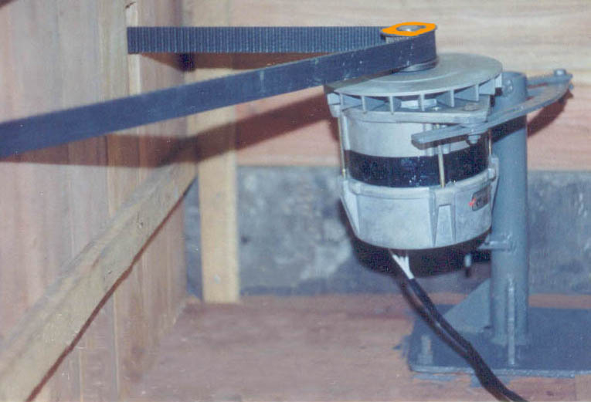
 | Automotive alternator

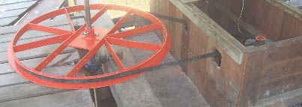
Pulley, 1.08 m (43 in) in diameter, and belt

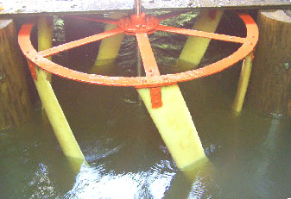 | Operation. This shows a 6-blade Gorlov Helical Turbine, mounted in a duct opened for viewing. The turbine is 1.12 m (44 in) in diameter and 0.83 m (33 in) in height. Normally, it operates while completely submerged.  The helical turbine is self-starting and smooth-running. Also, it rotates in the same direction regardless of the direction of the flow of water, so it can capture energy from both rising and falling tides.
6-blade Gorlov Helical Turbine

The result: accessible, affordable technology. This technology was developed in close collaboration with local technicians, workshops, and rural artisans. As a result, it is accessible to rural residents. About 90% of a tide-powered generating station can be built using locally available labor, materials, and equipment. The technically refined helical turbine blades are the only outside components.
Moreover, for local residents this technology is affordable. The cost of the structures and equipment for an individual tide-powered generating station is roughly that of a small, diesel-powered boat, which thousands of people in the region already own.
Expected outcome: many stations, many owners, many jobs. If this technology proves viable in the pilot phase, we expect that hundreds of small, tide-powered generating stations will be built near the mouth of the Amazon and elsewhere along the adjacent Atlantic coast. At those stations, rural residents would charge inexpensive automotive batteries for community and household use, as some already do in towns.
Because the technology is accessible, affordable, and inherently small-scale, these stations can be built, owned, and operated by hundreds of rural residents, who would use the energy for themselves and offer battery-charging service to their neighbors.
Moreover, the construction of tide-powered generating stations may be hastened by technical and financial assistance from private, electric concessionaires. Concessionaires would do this to help meet their deadlines under Law 10438, which requires them to make electric power available to all Brazilians.
In sum: the regional impact. Tide-energy technology will have broad, positive impact in the region. It uses a clean, renewable energy resource. It offers a viable, economical alternative to diesel generation, which harms the environment, and to solar panels, which are imported. Moreover, because this technology is largely indigenous, the construction and operation of tide-powered generating stations will foster small businesses and skilled labor to build and service them and create income for their owners.
o o o o o o o
The current situation: beginning the pilot phase. In technical terms, we have learned to manage tidewater effectively and build a helical turbine that generates reliably. We are ready to enter a pilot phase, during which time community members will manage and operate the field station for a year and we will monitor the full costs and benefits of the electric generation services provided.
Financially, our funding from the Ford Foundation ($150,000) has been concluded after an initial grant and two renewals, the maximum possible. We are now seeking funding to conduct the pilot phase.
Because this project is at an advanced stage, funding at this point will have a high return and will also make it possible to demonstrate this cutting-edge energy technology both to potential rural users and to concessionaires.
In sum: worldwide impact. The successful completion of the pilot phase of our project will produce results that are applicable at other suitable tidal sites and at suitable river sites, as well.
This would make helical turbine technology useful for small-scale, electric power generation in rural communities around the world.
Institutional affiliation: IPAM. The pilot phase will be associated with the Amazon Institute for Environmental Research (IPAM), a Brazilian NGO based in Belém. IPAM has received funding from international organizations, including USAID and WWF-UK, and is audited independently and by funders themselves. Researchers in this project are associated with Amazon institutions, including the Federal University of Pará and the Goeldi Museum.

